

ASSIGNMENT COVER SHEET

Unit Code | Unit Name |  |  | Due Date
TECO602 | Economic Environment of Business |  |  | 19/05/2026
Assignment Number: Assignment 1
Lecturer Name: Biplob Chowdhury |  |  | Tutor Name: Biplob Chowdhury
Students
Student Number | Given Name |  |  | Family Name
2025015971 | Dhiraj |  |  | Singh
Declaration
I/we have read and understood the Institute policy on assessment and academic honesty (which deals with issues such as plagiarism and recycling assignments) and certify that this assignment is my own work and complies with those policies.

- I/we hold a copy of this assignment which can be produced if the original is lost/damaged.
- This assignment is my/our original work and no part of it has been copied from any other students work or from any other source except where due acknowledgement is made.
- No part of this assignment has been written for me/us by any other person except where such collaboration has been authorised by the lecturer/teacher concerned.
- I/we have not previously submitted this work for this or any other course/unit.
- I/We give permission for this work to be reproduced, communicated, compared and archived for the purpose of detecting plagiarism.
- I/We give permission for a copy of my/our marked work to be retained by the Institute for review and comparison, including review by external examiners.

I/we understand that:
- Plagiarism is the presentation of the work, idea or creation of another person as though it is your own. It is a form of cheating and is a very serious academic offence that may lead to expulsion from the Institute. Plagiarised material can be drawn from, and presented in, written, graphic and visual form, including electronic data, and oral presentations. Plagiarism occurs when the origin of the material used is not appropriately cited.
- Plagiarism includes the act of assisting or allowing another person to plagiarise or to copy my/our work.
Student Signature(s)
Signature |  | Date | Signature |  | Date
1 |  | 19/05/2026 | 5
2 |  |  | 6
3 |  |  | 7
4 |  |  | 8

CRICOS Code: 02491D | TEQSA PRV 12059 | Add: Suite 1, Biomedical Building, 1 Central Ave, Eveleigh NSW 2015
Tel: + 61 2 9209 4888 | Fax: + 61 2 9209 4887 | E-mail: as@top.edu.au | Web: www.imc.edu.au
Top Education Group Ltd ACN 098 139 176 trading as Australian National Institute of Management and Commerce (IMC) and Top Education Institute (TOP)

Economic and Behavioural Analysis of Consumer Demand for Electric Vehicles in Australia

Introduction
As government and consumer governments look for alternatives to gas-fueled cars, electric vehicles (EVs) are growing in significance in the world's transport markets. With petrol costs going up and the environment constantly being a concern and developments in battery technology, many homes might be thinking about if buying an EV is cost effective. But the decision isn't as simple as it looks at the outset, as though consumers were just comparing the cost of fuel, they also need to consider charging stations, convenience, driving range and long-term operating costs as well as the purchase price (Dcceew, 2024).

The petrol prices in the market have also seen an increase giving EVs a competitive advantage, as well as geopolitical uncertainty as markets become uncertain due to recent events in the Middle East. Meanwhile, even with the prospect of long term savings associated with owning an EV, consumers are still affected by behavioural and practical considerations, and petrol vehicles are still popular (Iea, 2025).

This assignment will use economic principles, such as price elasticity of demand, substitute goods and behaviour economics, to examine consumers' decisions to purchase EVs and petrol vehicles. The role and impact of rising fuel costs and consumer demand changes on EV uptake in Australia is assessed (Oecd, 2024).

Question 1
Price Elasticity of Demand and Rising Petrol Prices
The responsiveness of the demand quantity to a price change is called the price elasticity of demand (PED). It illustrates how much consumers either reduce their purchase when prices increase or increase their purchase if prices fall. PED can be calculated using the following formula:
The formula for PED: Percentage Change in Quantity demanded / Percentage Change in Price.
Demand is said to be elastic if there is a large change in demand following a change in price. If there is little change in demand when there's a slight change in price, demand is inelastic. The notion has played a crucial role in explaining the potential effect of increasing petrol prices on the demand for EVs (Breder et al., 2025).

While EVs are different products from petrol vehicles, they are certainly related since they both serve the same purpose — providing private transportation. The higher the petrol price, the higher are the running costs of petrol vehicles.
Global oil markets have been jittery due to recent turmoil in the Middle East as a result of conflict. The World bank (2018) notes that geopolitical uncertainty may also lead to a decline in oil supply, therefore putting upward price pressure on fuel prices. The impact of increasing the cost of petrol on household transport costs could encourage consumers to look around for an alternative mode of transport including EVs.

Table 1: Price Elasticity of Demand and EV Demand
Petrol Price Level | Cost of Using Petrol Vehicle | Consumer Response | Demand for EVs
Low Petrol Prices | Lower running cost | Consumers continue using petrol cars | Lower demand for EVs
Moderate Petrol Prices | Increasing transport cost | Some consumers compare EV savings | Moderate demand for EVs
High Petrol Prices | Expensive fuel cost | More consumers switch to EVs | Higher demand for EVs

Diagram 1: Rising Petrol Prices and Demand for EVs
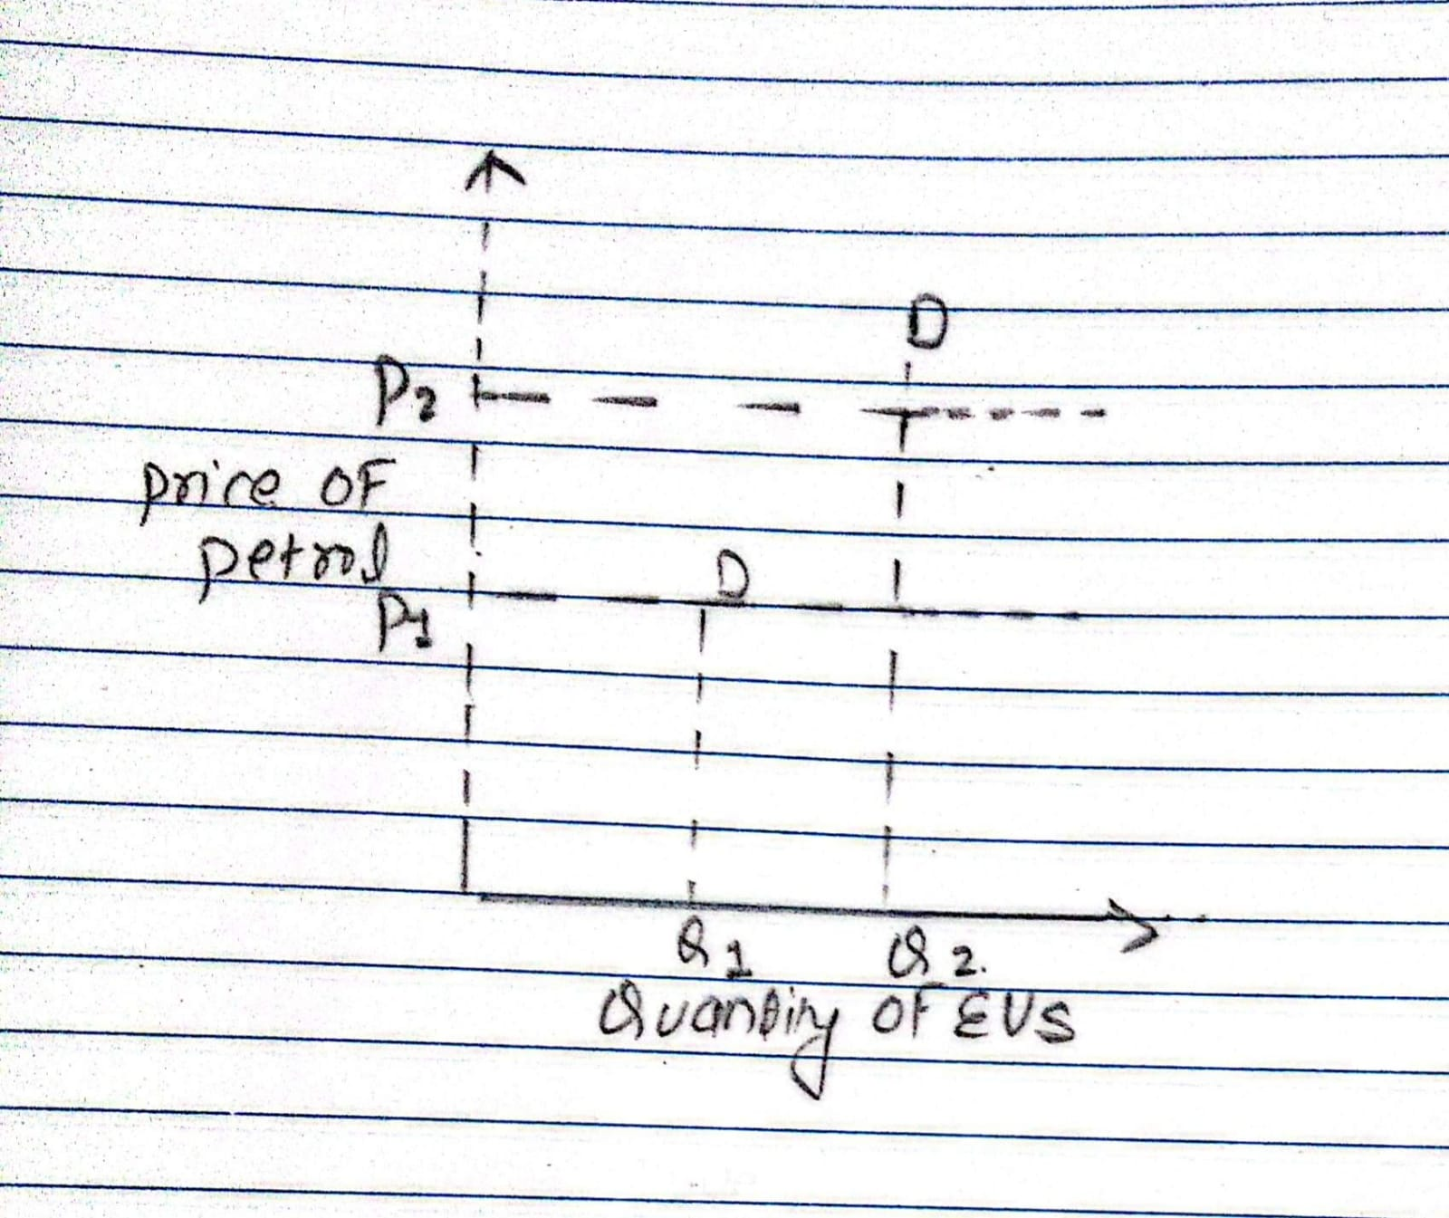

If, for instance, your home has a significant weekly expenditure already on petrol, a rise in petrol prices could make buying an EV much more affordable. The cost of electricity may be less volatile than the petrol price – giving EV owners potentially more stable transport costs over the long term. This may drive up demand for EVs.

As petrol prices go up, there will be more demand for EVs, this will cause the demand curve for EVs to shift from D1 to D2 on the diagram. When petrol-fuel vehicles become more costly, consumers shift towards EV purchase.

But not everyone is equal when it comes to how they react to price increases on petrol. There are households that are more vulnerable to price changes for energy products than others. This is based on a number of factors.

Firstly, income levels affect consumer responsiveness. Fuel and other expenses will be less significant for higher income households and so a larger petrol price increase will have less impact. Low and middle income households, however, could have a stronger reaction as expenditure on petrol is more “strained” in their budgets.

Secondly, driving habits affect the attractiveness of EVs. Frequent travelers and people who have long commutes might see more savings from making the switch to an EV since they are likely to incur fuel costs significantly larger on their daily driving. On the other hand, people who drive their car only a few times a week may not end up saving as much by paying more for an EV as they will get back out of pocket (Pelka et al., 2024).

Thirdly, access to charging infrastructure is an important factor. For suburban residents living in houses with garages, installing home charging stations is convenient and easy to do. But apartment dwellers or those who don't have a "home" or dedicated parking spot can be challenged to get a charge in. These consumers will continue to have low electric vehicle demand even in the event of a higher rise in petrol prices.

Another dimension of responsiveness is consumers' expectations of future prices. Households who think petrol costs are going to stay high will be more inclined to try and buy an EV. But if they think that the price rises are short-term, they could keep driving their petrol car (Barwick et al., 2024).

In the short run, the demand of EVs could be relatively inelastic as the consumers can't switch their existing cars immediately for the EVs. The cost of a new car is a large investment and for many households it may be uncertain or unaffordable to change their car. In the long run, however, consumers have time to make their decisions regarding the purchase of EVs, which increases their demand elasticity (Bailey et al., 2025).

The responsiveness of demand can also be impacted by government policies. Charging infrastructure investment and government incentives, including significant Australian government rebates and tax benefits, can lower the net price of EVs and improve the attractiveness of buying an electric car.

In general, costs of petroleum products will push up demand for EVs as consumers try to save money on transport costs, with no intention of exposing themselves to uncertainty in the fuel markets. This reaction varies, however, by income and accessibility to infrastructure, driving styles and expectations of the consumer.
Question 2
Are EVs and Petrol Vehicles Substitute Goods?

Satisfying similar needs can be supplied by substitute goods. Consumers have the opportunity to opt for another product when prices of one product begin to go up. There are two goods that are substitutes, EVs and petrol vehicles, both supplying the capability of private transport.

Some consumers switch their conversions from petrol into EVs when prices go up because the operating costs of EVs are lower. That indicates a positive cross-price elasticity of petrol cars and EVs. Yet at the same time, EVs and petrol vehicles are not perfect alternatives as they have different suitability, infrastructures, convenience, and cost.

One big distinction is the price of the purchase. Generally EVs are more expensive on the front end due to battery technology. In the case of EVs, though, the vehicle's overall fuel and maintenance expenses are typically lower (Li, 2025).
Table 2: Comparison between EVs and Petrol Vehicles
Factor | Electric Vehicles (EVs) | Petrol Vehicles
Purchase Price | Higher upfront cost | Lower upfront cost
Fuel Cost | Lower electricity cost | Higher petrol cost
Maintenance | Lower maintenance | Higher servicing cost
Refueling/Charging | Longer charging time | Fast refueling
Infrastructure | Limited charging stations | Widely available petrol stations
Environmental Impact | Lower emissions | Higher emissions
Best Suited For | Urban/suburban households | Long-distance/regional drivers

Diagram 2: Substitution between Petrol Vehicles and EVs

demand for ev increases
consumer compare alternative
consumer switch to evs
Petrol vehicles become more expensive to operate

Rise in petrol prices

Convenience is a factor in substitution, too. The fuel quality is fairly good and petrol stations are plentiful throughout Australia. In comparison, charging an EV is still in its infancy, and it can take longer to charge an EV.

Suburban dwellers who have garages and consistent drive times may have close substitutes with EVs as their home of charging is convenient and cost-effective. For those living in apartments or commuters in other parts of the region who do not park their vehicles on site, however, petrol cars might be more convenient as there is not enough charging infrastructure and range sessions are still a worry (Thaichon, 2024).

Another factor is the familiarity of consumers. Petrol vehicles are more popular with many consumers as they are more familiar with how the vehicles run and where to get servicing done.

At the macroeconomic level, EVs and petrol vehicles are considered substitute goods as they serve the same purpose: to provide transportation. These are imperfect substitutes, however, as consumers make choices for realities don't fit perfectly with idealities and it may be costlier in practice.

Question 3: Behavioural Economics and Consumer Preference for Petrol Vehicles
In traditional economic theory assumptions prevail that consumers act rationally and are able to compare costs and benefits in order to maximize their utilities. The difference in behavioural economics is that it acknowledges that as a consumer you are guided by emotion, habits, mental quirks and uncertainties.

Despite the fact that the long-term costs to operate an EV may be lower, a number of consumers still seem to favor a petrol-powered vehicle. Habit is one factor to keep in mind. Consumers are already used to petrol cars and established practices like filling up petrol at oil pumps. Therefore, it is difficult to convince people to change to new technology (Fridstrøm & Østli, 2021).

Consumer behavior is affected as well by 'status quo bias'. People tend to stick with their existing, known behaviors instead of adopting new ones that are not known. The consumers' knowledge of petrol vehicles makes traveling in them safer and more reliable.

Other key behavioral dynamics are losses. Consumers are very tuned into potential drawbacks of EVs like charging convenience, battery replacement expense, and uncertainty over resale value. Meanwhile, they might also be underestimating the potential savings that will accrue on their future petrol and maintenance costs.

The importance of present bias in explaining consumer behaviour. While most people would obviously consider the upfront cost of their EV much higher than the cost of their direct fuel savings, others tend to emphasize the purchase price of their EV. While EVs can save on transportation expenses over time, the upfront financial expense is more often than not a priority for consumers (Zhang et al., 2024).

In addition to the uncertainty about charging infrastructure and battery range, purchasing an EV is also a costly endeavor. There can be some consumers that wait for better technologies until they can afford EVs.

Conclusion
Overall, behavioural economics demonstrates that consumers are not always perfectly rational, as described in economic theory. Even with increasing economic benefits from EVs, factors like habit, status quo bias, loss aversion, present bias, and uncertainty continue to sustain the continued dominance of petrol vehicles.

As seen, people are more and more interested in EVs because of the economic trends, rising fuel costs, and awareness of the environmental issues. The rise in petrol prices may lead some consumers to switch to EVs to cost save over the long term, in part because of that elasticity (Malik et al., 2025).

Simultaneously EVs and petrol vehicles are considered as substitute goods since both meet the need of private transportation. They are, however, not particularly ideal replacements as the price paid may differ, there is a lack of suitable charging infrastructure, consumers' habits are not uniform, and household circumstances affect customer choice.

Behavioural economics also offers insight into the value which many consumers still place on petrol vehicles even if their cost of ownership may be bound to rise in the future. Consumers can easily become resistant to new technologies due to habit, status quo bias, present bias, and uncertainty (World Bank, 2025).

So, it's up to the individual household to decide whether now's the best time to purchase an EV. Increasing fuel prices and decreasing running costs make EV ownership increasingly more attractive for some consumers. Certain other participants are still reluctant when buying electric cars, including high initial costs, the lack of charging stations, and uncertainty about new technology, keeping the preference for petrol cars.

References
Bailey, M. R., Brown, D. P., Myers, E., Shaffer, B., & Wolak, F. A. (2025). Electric Vehicles and the Energy Transition: Unintended Consequences of Time-of-Use Pricing. https://fawolak.org/pdf/unintended_consequences_of_tou_pricing.pdf
Barwick, P. J., Kwon, H.-S., & Li, S. (2024). ATTRIBUTE-BASED SUBSIDIES AND MARKET POWER: AN APPLICATION TO ELECTRIC VEHICLES. https://www.nber.org/system/files/working_papers/w32264/w32264.pdf
Breder, M. S., Hofmann, A., Bucksteeg, M., & Weber, C. (2025). Economic analysis of behavioral aspects of electromobility with a focus on consumers – A review. Sciencedirect, 62. https://www.sciencedirect.com/science/article/pii/S2211467X25003165
Dcceew. (2024). National Electric Vehicle Strategy. Australian Government. https://www.dcceew.gov.au/sites/default/files/documents/national-electric-vehicle-strategy-annual-update-2024-25.pdf
Fridstrøm, L., & Østli, V. (2021). Direct and cross price elasticities of demand for gasoline, diesel, hybrid and battery electric cars: the case of Norway. European Transport Research Review, 13. https://link.springer.com/article/10.1186/s12544-020-00454-2
Iea. (2025). Global EV Outlook 2025. https://iea.blob.core.windows.net/assets/7ea38b60-3033-42a6-9589-71134f4229f4/GlobalEVOutlook2025.pdf
Li, H. (2025). An In-Depth Analysis of the Transition from Gasoline Vehicles to Electric Vehicles (EVs): Factors Influencing Consumer Choices and Market Dynamics. Applied and Computational Engineering. https://www.researchgate.net/publication/389417914_An_In-Depth_Analysis_of_the_Transition_from_Gasoline_Vehicles_to_Electric_Vehicles_EVs_Factors_Influencing_Consumer_Choices_and_Market_Dynamics
Malik, M. A. I., Kalam, M. A., B, A. I., Zeeshan, S., & Zahidi, S. Q. R. (2025). Energy transition towards electric vehicle technology: Recent advancements. Energy Reports, 13. https://www.sciencedirect.com/science/article/pii/S2352484725001118
Oecd. (2024). Household Transport Choices: New empirical evidence and policy implications for sustainable behaviour. Organisation for Economic Co-Operation and Development. https://one.oecd.org/document/ENV/WKP(2024)16/en/pdf
Pelka, S., Bosch, A., Chappin, E. J. L., Liesenhoff, F., Kühnbach, M., & Vries, L. J. de. (2024). To charge or not to charge? Using Prospect Theory to model the tradeoffs of electric vehicle users. Sustainability Science. https://link.springer.com/article/10.1007/s11625-023-01432-y
Thaichon, P. (2024). Petrol, pricing and parking_ why so many outer suburban residents are opting for EVs. Researchgate. https://www.researchgate.net/publication/381707958_Petrol_pricing_and_parking_why_so_many_outer_suburban_residents_are_opting_for_EVs
World bank. (2018). The Effects of Geopolitical Oil Supply Shocks. https://openknowledge.worldbank.org/server/api/core/bitstreams/41246f76-a94b-4fc6-b411-260878758ae6/content
World Bank. (2025). Commodity Markets Outlook. https://thedocs.worldbank.org/en/doc/1b388949805c9a0ae3736bdacb32ea94-0050012025/original/CMO-April-2025.pdf
Zhang, S., Du, Y., & Wang, L. (2024). Using Consumer Loss Aversion to Investigate the Effect of Stackelberg Pricing for New-Energy Vehicles. Energies, 17(17). https://www.mdpi.com/1996-1073/17/17/4445

